Rodney Farrow

Tax Policy Paper:

Earned Income Tax Credit

Econ 4353

Often I hear people talk about how much they hate taxes but I rarely hear people talk about subsidies. A subsidy is simply money given to someone or an industry, usually by a governing body, to aid in economic activity by effectively reducing the costs of something. There are many different subsidies given by the government but for this report I will discuss one of the largest subsidy programs in the United States, the Earned Income Tax Credit (EITC). In the following paragraphs I will discuss the history of the EITC, how the policy works, its effects of different economic behaviors, and associated levels of equity and efficiency of the Earned Income Tax Credit.

The EITC was enacted in 1975 by the Tax Reduction Act of 1975 signed by the Ford Administration, with the intention of reducing the burden of rising costs of food and energy in the 1970’s and incentivizing work among low income earners (Scott, 2007). However before the creation of the EITC there was discussion of a Negative Income Tax, proposed by Milton Friedman, which outlined that people who earned below a certain amount of income should receive a cash benefit to supplement to a minimum income level. This plan is not much different from the EITC, except that it could have potentially given rise to dis-incentive to work by placing those slightly above the income level outside of the zone for receiving aid which would create an issue where people would rather just be receive government assistance than work. The EITC has expanded and become more generous over the past 40 years. In 1975 the EITC was considered only a work bonus, however expansion of the subsidy turned it into a one of the largest wealth transfer programs in the United States. “Before the 1990’s the EITC’s structure would limit is ability to reduce poverty among families of different sizes because of its original design that did not account for family size (Crandall and Hollick, 2016).” The EITC works by providing a subsidy to people who are working and is exceptionally generous to those with children. The main recipients of the EITC are working class mothers with children and large families although people from all demographics receive the credit. This Graph shows how the benefits are calculated for single people with no children to Married Couples with 3 or more children. Married couples benefit heavily from the policy while those who are single benefit less and begin to lose benefits at earlier levels of income earnings. Also there is an egregious difference in the value of credit people with children receive compared to those who don’t have children which displays a more pro-child, pro-marriage agenda.  “The phase-in rate, phase-out rate, and maximum credit are determined by the number of children that the filer has, while the point that the credit begins to phase-out depends on whether the filer is married (along with the number of children) (Bipartisan Policy Center, 2014).”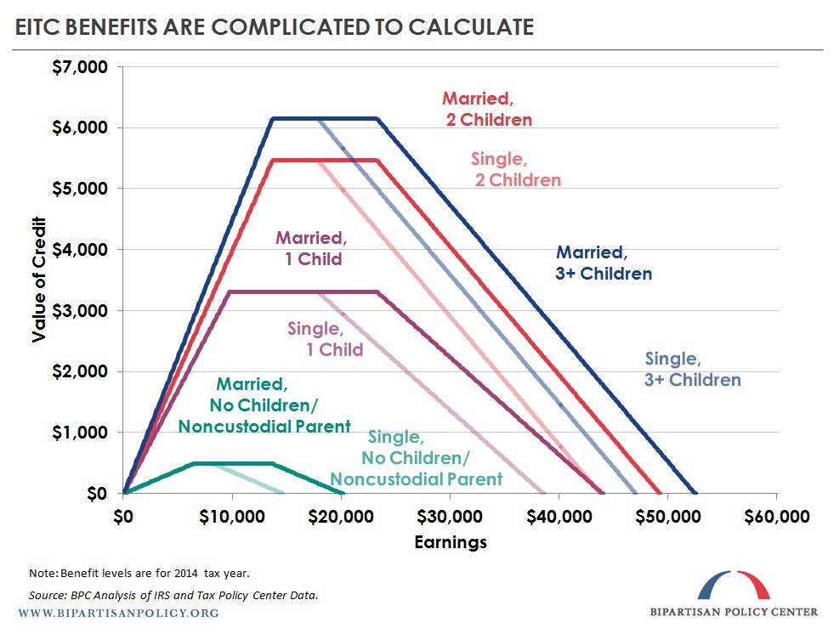

Each year millions of families receive the benefits of the EITC and in order to be eligible you must file taxes and have a job. However some single low income earners are unaware of the benefits they could receive if they applied. I myself used to not file taxes because I didn’t think I made enough to get a return because I was misinformed. Many people may take advantage of the EITC but for single filers the benefits received is not worth much which I believe is a downfall of the policy because an increasing number of people are deciding to have families later, reducing their overall lifetime benefits.

The Earned Income Tax Credit, as stated in previously, is a method of wealth redistribution with an emphasis on working. The effects of the EITC on work or the supply of labor are interesting because it is a subsidy that requires people to work, so in theory it should increase the available labor supply, demand for jobs, and the number of hours worked by individuals who fall into the lower income category, specifically those with children because of the drastic increases in credits received, while not having much effect on the labor supply of those who have reduced credits due to phase out levels for higher income individuals. In a study from 2005 by Cancian, and Levinson, they concluded there was “no evidence of increased employment: for all of our samples and specifications the effect of the EITC on employment appears to be tiny, statistically insignificant, and negative (Cancian and Levinson, 2005).” It’s important to note that the EITC may have income and substitution effects that affect how people work. Some people may work more or less depending upon their value of leisure. By increasing what someone can earn they would likely work more due to their value of leisure decreasing and the value of working increasing which would be the substitution effect. However when income increases, it is likely that consumers will consume more items, which include leisure, which could mean that as incomes increases, people work more, then begin to work less which is why it can be difficult to measure the impacts of EITC on labor supply. However “if taxpayers' income places them in the plateau region, they would receive the same amount of the EITC regardless of the number of hours worked. In this region, the EITC neither increases nor decreases hourly wages, and hence has no substitution effect. But since workers still receives the credit, then according to the income effect, they will work fewer hours. Also if recipients' income places them in the phase-out region of the credit, the value of the credit falls for each additional hour worked, and according to the substitution effect, "leisure" became less costly, and so workers work less. In addition, in the phase-out region, the credit is still available, and so according to the income effect, workers would also be encouraged to work fewer hours. Hence, overall, economic theory suggests that both the income and substitution effects will encourage workers to cut back on the hours they work. (Crandall-Hollick, 2016)” The demographics of different workers plays a role in the amount of hours worked. Because single mothers benefit the most, they would potentially work the most however because of the types of jobs available at low levels of income, their usually is no room for flexibility when it comes to work, as someone who is married with children may have the ability to afford childcare, and have the ability to work more or less depending on a number of factors such as spouses income, which effects eligibility and phase out rates, elasticity of leisure, and skill set. The effects on labor supply may be relatively small, but the EITC is effective at providing low income individuals and families with a subsidy that helps support them in a landscape where there are growing levels of opportunity gaps, decreased levels of economic mobility, and increased levels of income inequality.

Evaluating the EITC on the basis of efficiency and equity allows us to examine more closely the differences in credits received by demographic. As stated before the EITC is one of the largest credits given to low income families, which is aimed at decreasing levels of poverty, in which it does. However there are discrepancies in levels of equity received by those are who are married, unmarried, those who have children and those who don’t. Those who remain near federal poverty levels that are unmarried and have no children hardly receive any benefits compared to those who are unmarried with children. There is not much difference between those who are married with children and those who are not married with children as they receive similar benefits due to the child reduction staying the same regardless of marriage. Using data from CRS analysis of the 2013 Current Population Survey, Crandall-Hollick found that the percent change in poverty rates from the EITC decreased by 0.14 percentage points in single childless workers, versus married childless workers decreasing by 1.39 percentage points which shows that there is some inequity between single childless and married childless workers. Also it’s worth pointing out that the data found that those who were single and married with children found much larger decreases in their poverty rates, by 15 to 20 percentage points, because they have children, which is an incredibly large level of inequality for those without children. “As incomes rise to around $25,000, the variation in effective tax rates falls among equivalent families, as fewer tax filers are eligible for the EITC or are eligible for a smaller EITC due to the phase out of the credit. In addition, the child tax credit further increases horizontal inequity between those with and without children. This has led researchers to conclude that "the clearest change that would increase horizontal equity is a larger EITC for single workers and childless couples (Crandall-Hollick, 2016). In a graph shown earlier, I quickly summarized how credits increase, plateau, and decrease as income increases. The EITC is effective at moving income toward low income families, but the movement of resources toward individuals without children is quite low. Also, regardless if you have children or not, it is not easy to calculate your credit with 100 percent accuracy because of the various levels of phase in and phase out credits, with regards to levels of income and number of children, and if you’re married or not. “The IRS estimates that in FY2013, 22% to 26% of EITC payments-between $13.3 billion and $15.6 billion-were issued improperly (Crandall-Hollick, 2016).” As a personal statement, my father would claim me, and my 2 nieces on his personal tax return; however, neither of them lived with us when I was younger. Of course he no longer can do this, but it is interesting because the most common error reported was “claiming a child who did not fulfill the residency requirement. (Crandall-Hollick, 2016).” Moreover it is important to understand that the issue of efficiency not only lies with those prepares taxes but with those who prepare taxes for other people. In an EITC study compiled in 2006 by the IRS states that “among paid tax preparers, unenrolled preparers were both the most common type of tax preparers of EITC returns and among the most prone to erroneous claims of the credit (Crandall-Hollick, 2016).” Pareto efficiency means that we should be able to make someone or a set of someone’s better off while not making another individual worse off. Because of the nature of the credit, and how it could influence peoples work decisions, I do not believe the credit to be Pareto efficient. This is due to the policy reducing credits at phase out rates for those in high income areas that may still be subject to under productive parts of areas, resulting in low economic mobility, although the credit payout is still the same based on criteria. Although there are inefficiencies within the system there is still no denying that it is effective at passing income to low income earning individuals and families. The amount of income overpaid to people through the EITC program is miniscule compared to its impacts on poverty relief.

The earned income tax credit is something that has helped me and my family obtain things we have otherwise not been able to obtain without it. Growing up, I was the only child at home but my father was the only one who ever worked, which used to be common. My father graduated high school but never went to college which means his income was low. Growing up I remember the beginning of the year being more like Christmas than Christmas day itself, because it was tax season and as soon as my dad would get his w-2 he would go to Jackson Hewitt to file. Without the EITC, my life, and millions of other Americans would be much different. Thanks to the EITC, I was able to somewhat keep up with my peers socioeconomically, however without it, due to the stark levels of income inequality, and the maturity level of children, I don’t know how I would have fared socially. I was bullied in middle and high school, so I could only imagine it being worse had I not been able to stay just a few steps behind the Jones’. I believe the EITC is a necessary ingredient in the concoction for a successful set of social safety nets that provide opportunities for low income earners to reduce their overall level of poverty and increase their economic mobility. Due to the increasing level of income inequality, opportunity gap, and economic mobility the EITC is more important than ever in transferring income. We need more policies like the EITC that encourages work or improvements to the efficiency and equity of the policy itself like expanding the childless credit to help those who may want to go back to school, and make it easier to file taxes to reduce unnecessary overpayments. Of course there will be inefficiencies to the system as no system is perfect but once again I believe this system is more effective than transferring wealth than taking it away. Of course you want zero excess burden when dealing with tax policy, however if the burden is very small and the benefit is large, which is the case in the EITC, then I believe it is worth it to enact

Akabas, S. (2014) Background on the EITC. Bipartisan Policy Center

Cancian M., Levison A. (2005) Labor Supply Effects of the Earned Income Tax Credit: Evidence from Wisconsin’s Supplemental Benefit for Families with Three Children. NBER

Crandall-Hollick, M. (2016) Earned Income Tax Credit (EITC): An Economic Analysis. Congressional Research Service

Rosen, H. S, & Gayer, T. (2014). *Public finance.* Tenth edition. New York, NY: McGraw-Hill Education

Scott, C. (2007) Earned Income Tax Credit (EITC): An Overview. Congressional Research Service